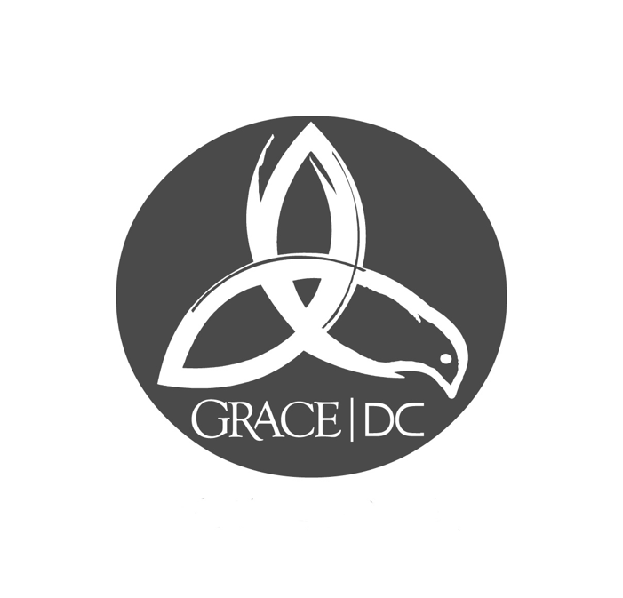
Grace Presbyterian Church
of Washington, DC
637 Indiana Ave. NW, Suite 300
Washington, DC 20004
202.386.7637
office@gracedc.net
www.gracedc.net

Date:

One purpose of the Grace DC Diaconate is to assist people in the Grace DC community with financial needs using money collected each month during the worship service (the Deacon's Fund). This money has been set aside to use for special financial needs in our community, including helping members and regular attenders to pay for Grace DC's counseling services. We do not want any of our members or regular attenders to decline counseling for financial reasons, and encourage those who need financial help to seek it.

The questions below are designed to ensure that we are stewarding financial resources as carefully as possible so that we might help as many as we can. To that end, please answer these questions as thoroughly as possible and submit this form via email to diaconate@gracedc.net, with the subject line: Counseling.

1) Are you currently a member or regular attender in the Grace DC network? How long have you been a part of our community? (Note: this assistance is intended for members or regular attenders only.)

2) The cost for one hour of counseling at Grace DC is $120.00. How much of that are you able to pay? We ask that you contribute the maximum amount possible and trust that you will tighten expenses where necessary in order to do so.

3) Are you experiencing unusual financial hardship at this time (e.g. medical bills, credit card debt)? What is your plan for paying for these expenses?

4) Have you documented your income and expenses over the course of a month and developed a budget accordingly? If you need assistance creating and/or managing a budget, please note that here; the diaconate is available to help you.

Important Note: The Diaconate approves financial assistance for Counseling in five session increments. Assistance for additional sessions may be available. When the current group of approved sessions nears completion, you and our counselor will discuss if more sessions are needed. If it is determined that this is the case and you need continued financial assistance, please contact the Grace DC Diaconate at the email address above and we will walk you through the process for renewal. Please know anything you share with the counselor is confidential; the counselor never shares information about the counseling session with the Diaconate.

